**HW2 Huaiyu Wang**

3.1

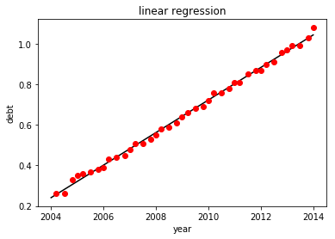

Output: [3.93601056]

w= 8.03244175e-02

b=-1.60729045e+02

In 2050, the student loan debt will be 3.93601056

Code here:

import csv

from pylab import *

def main():

rfile = 'student_debt.csv'

csvfile = open(rfile, 'rt')

data = csv.reader(csvfile, delimiter = ',')

X = []

Y = []

for i, row in enumerate(data):

X.append(float(row[0]))

Y.append(float(row[1]))

X = array(X)

X_temp = X[:]

Y = array(Y)

one = ones((len(X)))

X = row_stack((one,X))

X = X.T

Y = reshape(Y, (len(Y),1))

weight = linearfit(X,Y)

print (weight)

it = np.arange(2004, 2015, 1)

plt.ylabel('debt')

plt.xlabel('year')

plt.title('linear regression')

g = weight[1] * it + weight[0]

plt.plot(it, g, 'k')

plt.plot(X_temp, Y, 'ro')

plt.show()

plt.close()

print (weight[1] * 2050 + weight[0])

def linearfit(X, Y):

W =dot(inv(dot(X.T, X)),dot(X.T,Y))

return W

main()

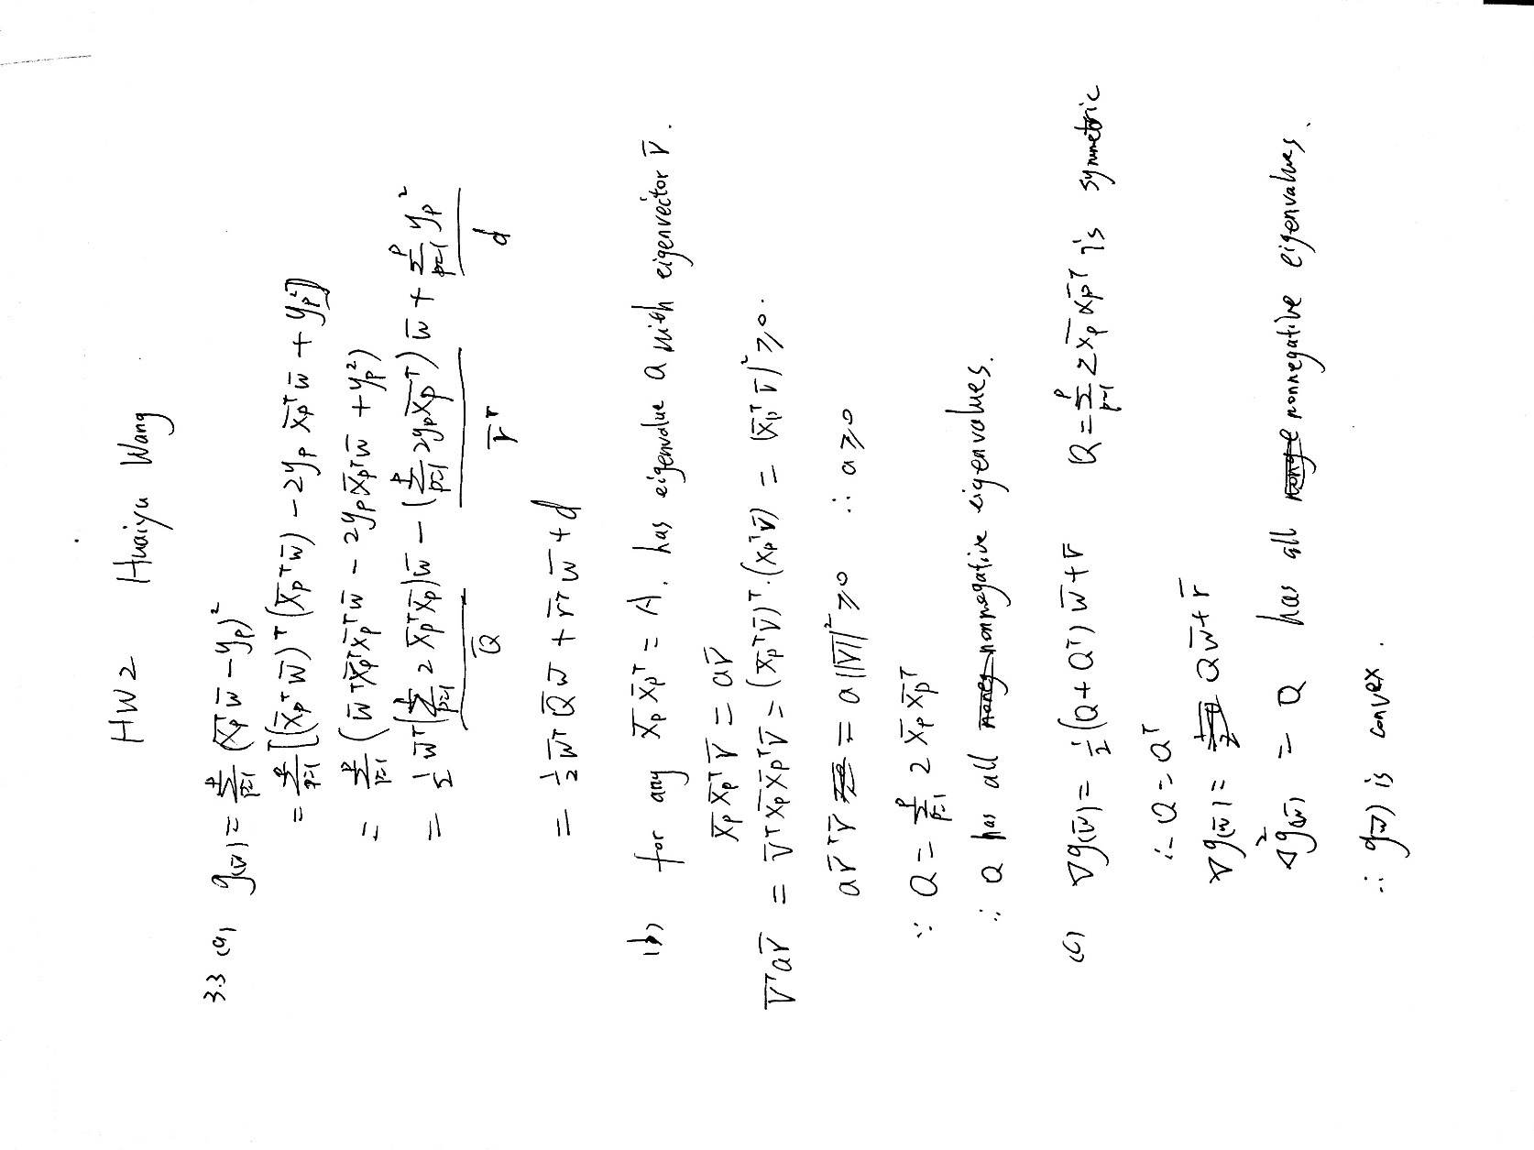

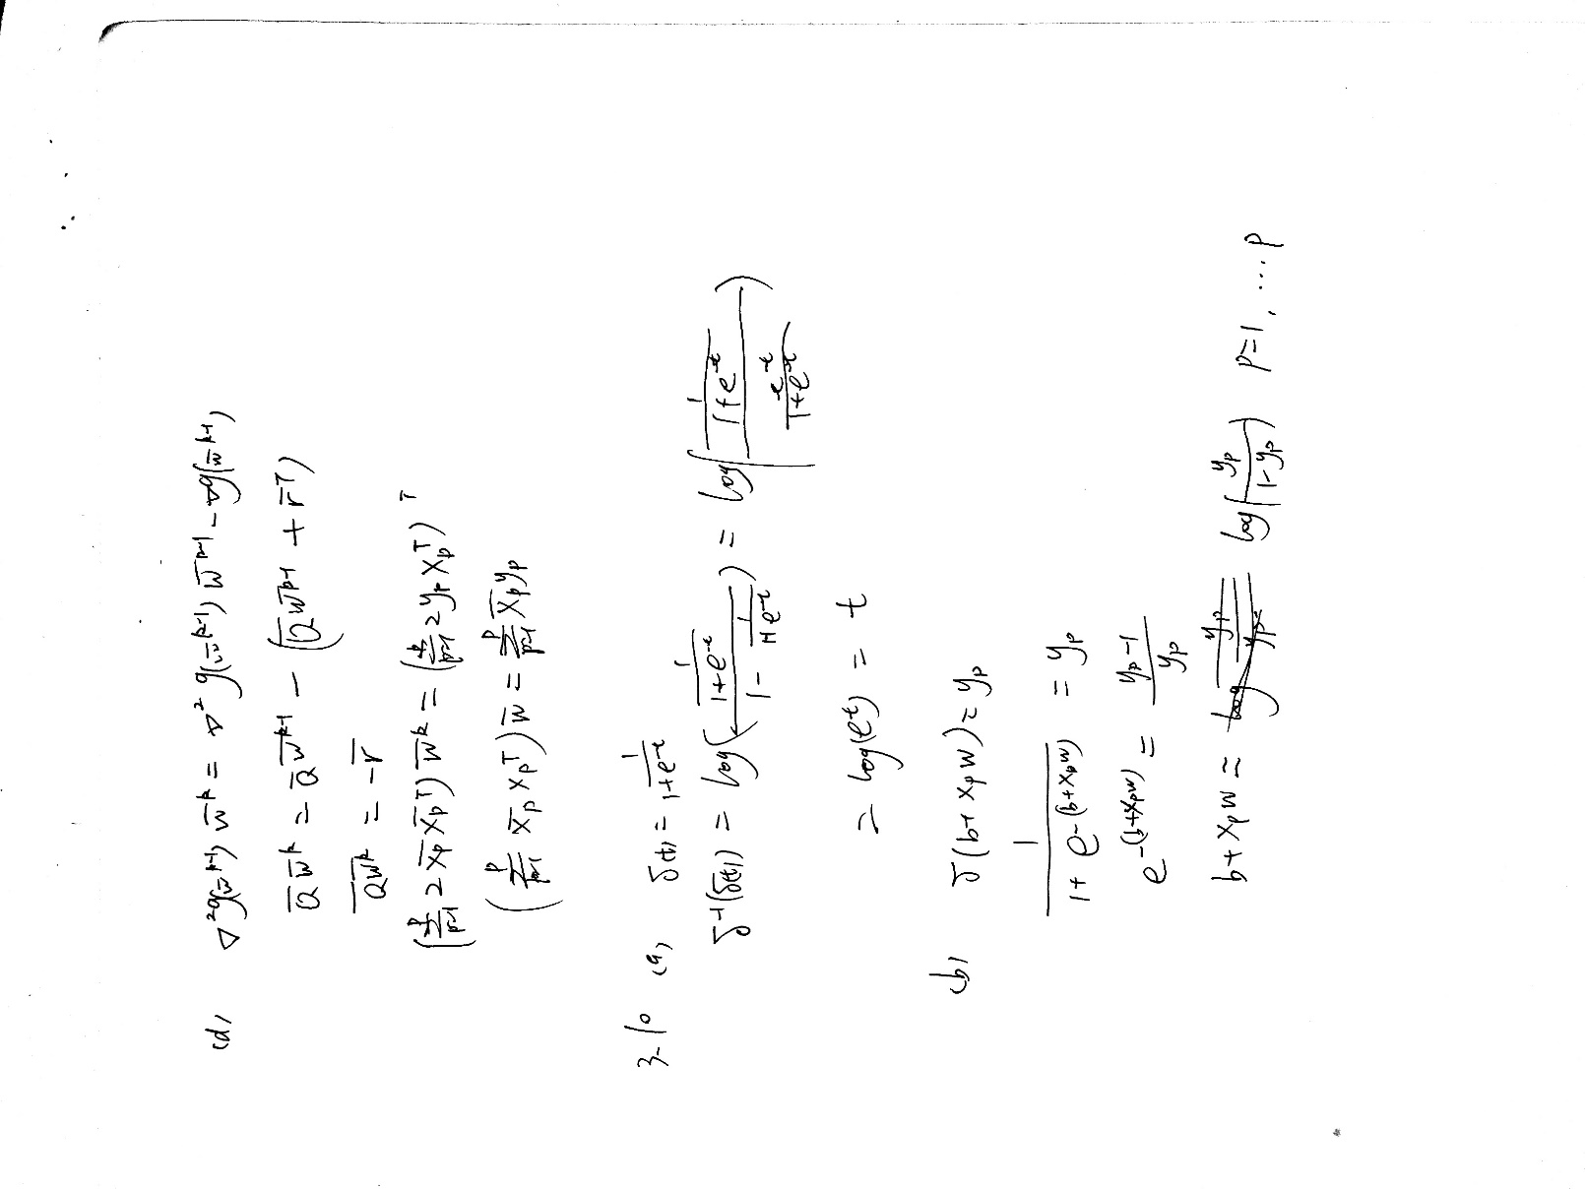

（c）

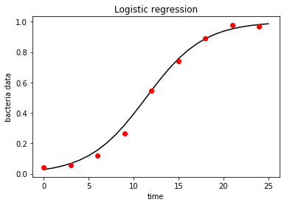

Code here：

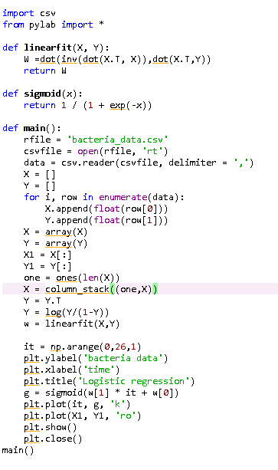

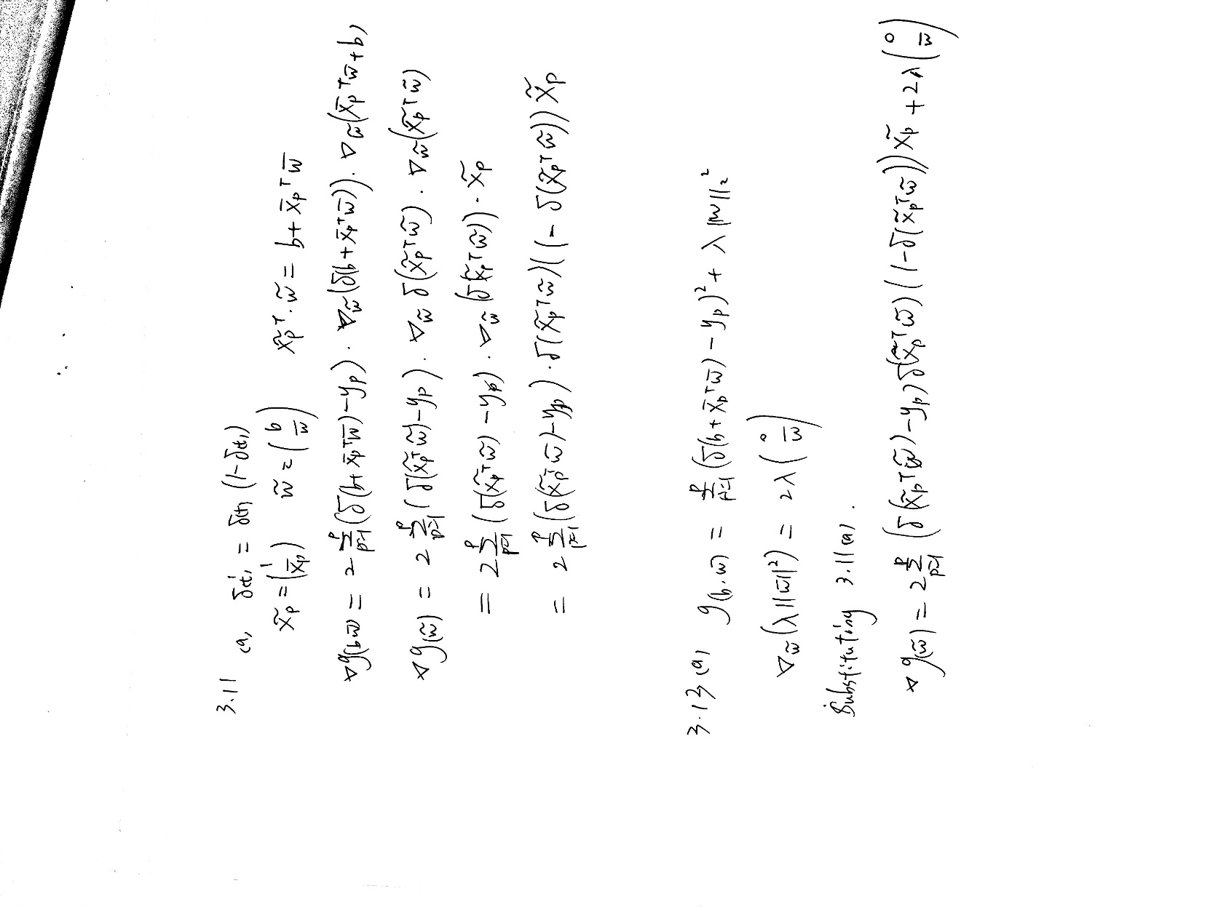

（b）

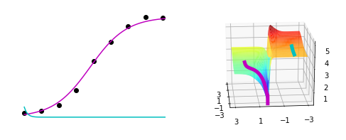

# YOUR CODE GOES HERE - compute gradient

grad=0

for p in range(0,np.shape(X)[0]):

grad+=2*(s(np.dot(X[p].T,w))-y[p])*s(np.dot(X[p].T,w))*(1-s(np.dot(X[p].T,w)))*X[p]

grad=np.asarray(grad)

grad.shape=(2,1)

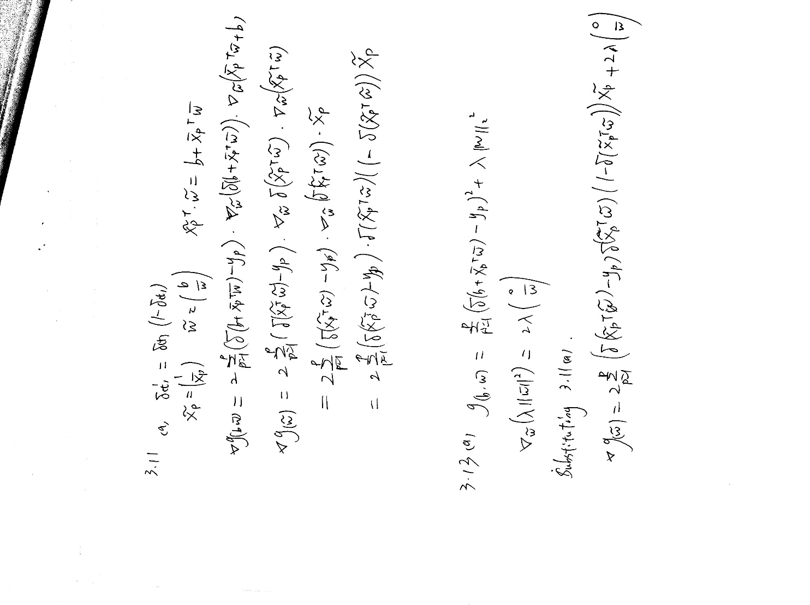

（b）

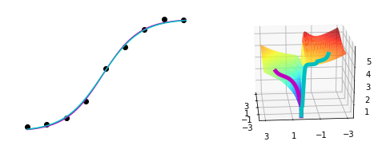

Code here：

def gradient_descent(X,y,w0,lam):

w_path = [] # container for weights learned at each iteration

cost_path = [] # container for associated objective values at each iteration

w_path.append(w0)

cost = compute_cost(w0)

cost_path.append(cost)

w= w0

w1= np.array([0,0])

w1.shape = (2,1)

# start gradient descent loop

max_its =20000

alpha = 10**(-2)

for k in range(max_its):

# YOUR CODE GOES HERE - compute gradient

grad=0

for p in range(0,np.shape(X)[0]):

grad+=2*(s(np.dot(X[p].T,w))-y[p])*s(np.dot(X[p].T,w))*(1-s(np.dot(X[p].T,w)))*X[p]

grad=np.asarray(grad)

grad.shape=(2,1)

w1[1]=w[1]

grad=grad+0.05*w1

# take gradient step

w = w - alpha*grad

# update path containers

w_path.append(w)

cost = compute_cost(w)

cost_path.append(cost)

# reshape containers for use in plotting in 3d

w_path = np.asarray(w_path)

w_path.shape = (np.shape(w_path)[0],2)

cost_path = np.asarray(cost_path)

cost_path.shape = (np.size(cost_path),1)

return w_path,cost_path